Tailoring Your Resume

For a successful job search, it is best to adjust your resume for each position you apply to, instead of using an identical version for every application. This is because the purpose of a resume is to highlight your experience and qualifications relevant to a particular position. Follow the instructions below and use the table on page 2 to help you tailor your resume toward particular positions.

- Find a position you want to apply to. Now, read, re-read, and re-re-read the position description.
- What are the main duties of the position? What are the qualifications? Identify these keywords and phrases and add them to column 1 in the table.
- In column 2, write an example in which you demonstrated the skill or ability. Examples should be from work experiences but can also include volunteering, leadership/ extracurricular roles, and academics.
- In column 3, craft a statement that you could use on your resume to describe the example in column 3. Start with a verb that highlights the relevant skill, then describe the task/duty. End by explaining the result. See examples:

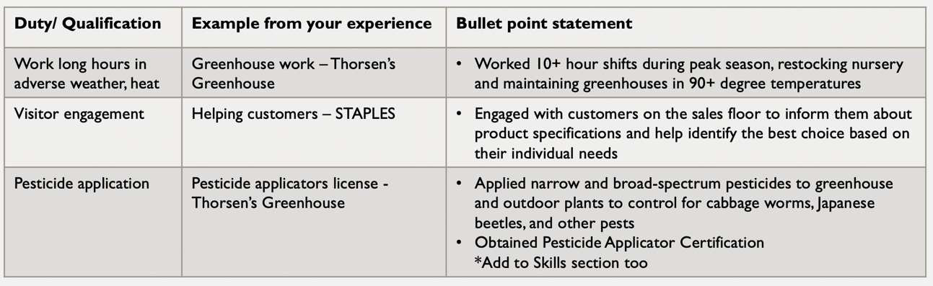

- After completing your table, you should have a clearer sense of which experiences to list on your tailored resume. Update your resume using the bullet point statements you created.

Duty/ Qualification | Example from your experience | Bullet point statement

